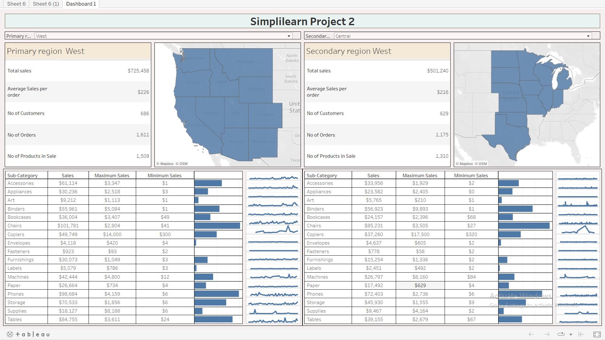

https://public.tableau.com/app/profile/kshitij.chavan/viz/Simpli_1/Dashboard1?publish=yes